Hugo’s Soaring Summary #2 for March 2014

Dear Soaring Friends April 2014
This is my second report for 2014.

Outline and Contents
My previous summary (#1), which I have sent out in early March covered all the flights to the end of February of 2014.

1. March Flights (1)

March is always a busy month for us and I did not have a chance to do any soaring other than the flight I took on Monday, March 10th as a passenger in Karl Striedieck’s Duo Discus (KS) during the Senior Contest at the Seminole Lake Glider Port*.

*Located in Central Florida near Clermont, ~20 miles West of Orlando and about a 4 hour drive to the North from our home in Bonita Springs.

1.1 Flight from Monday, 3-10-2014

1.1.1 Introduction

The previous time I flew with Karl was in March of 2012 and I considered our 5 ½ hours flight the highlight of my 2012 soaring year. It was truly an introduction to the “Higher Education” in soaring and I learned more during that flight than I have in many years of flying by myself. Not just about racing, but about the fundamentals of how to become a more efficient cross country pilot.

After this experience I was anxious to book another such flight with Karl for March of 2013. Unfortunately I was too late when I contacted him in January of 2013. Learning from this mistake, I got in touch with him in early November of 2013 for March of 2014, and this time he had two days open and I picked Monday, March 10th.

When Cornelia and I arrived at the glider port on Monday morning, I was all excited to have a chance at another such a flight with Karl. However, in the pilots meeting we learned that the soaring forecast was not as good as when I had checked it the previous day. And around 14:00, with all the ~60 contest gliders lined up on the field, the contest was cancelled for the day.

Frankly, I did not think that the conditions were all that bad since there was obviously some lift around. I spotted a couple of birds soaring to the East of the airfield and the “sniffer” glider could stay airborne as well. However, there were some stratus clouds moving in from the West and shading a good portion of the flying area and the rest of the sky was blue. Further to the North and further South there were signs of a few clouds developing, even though the bases looked very low <3000’.

When Karl and a few other pilots decided to practice anyway I was delighted because I was looking forward for us to fly in challenging conditions, since this is one of my weak areas.

1.1.2 Summary Chart of Karl’s Flight from March 10th, 2014
- Soaring Conditions: C (Marginal). The sky was basically blue and there was a stratus cover moving in from the West. The wind was steady from the West at ~7 kts.
- Route /Task: Seminole – Groveland– Grass Roots – Flying Baron (Leesburg) - Groveland – Seminole – Burntwood – Seminole.
- Take-Off: 15:39
- Landing: 17:42
- Duration: 2 hours, 3 minutes, (~2.0 h, including tow)
- Distance: <100NM roundtrip
- Release Altitude: ~2000’
- Altitude Max: ~4565’
- Altitude Min: ~1350’
- Airport: Seminole. Runway: 3-6 for take-off and 3-6 for landing.
- Comments: A challenging flight, but Karl saved us from landing out twice

1.1.3 BLIP - Maps showing Cumulus Potential, Cloud Base and Wind
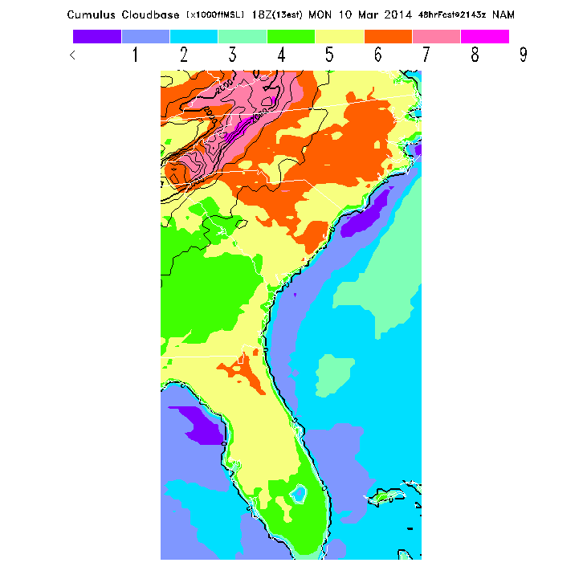
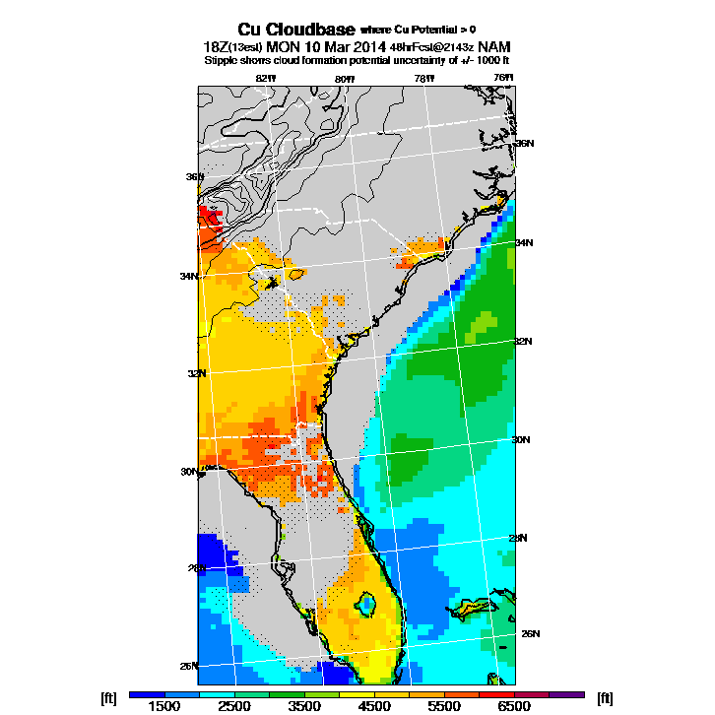
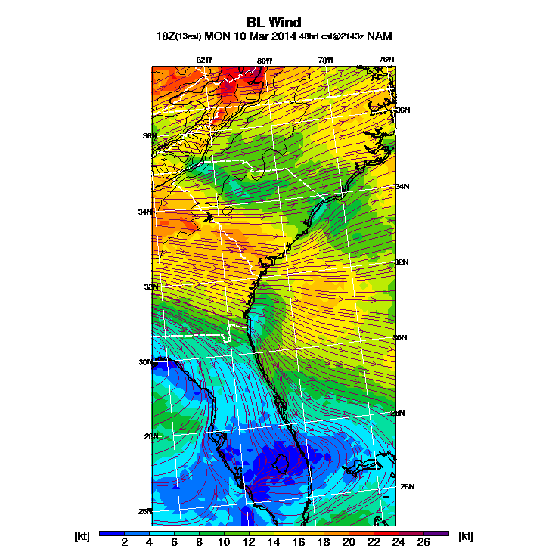
As shown below, the CU-potential in the Seminole area was low (Blue conditions) but the cloud-base in the surrounding areas was in the range from 3000’ to 5000’. The wind was <10 kts from the West. This is not the most recent forecast because it does not show the higher level air mass pushing in from the West

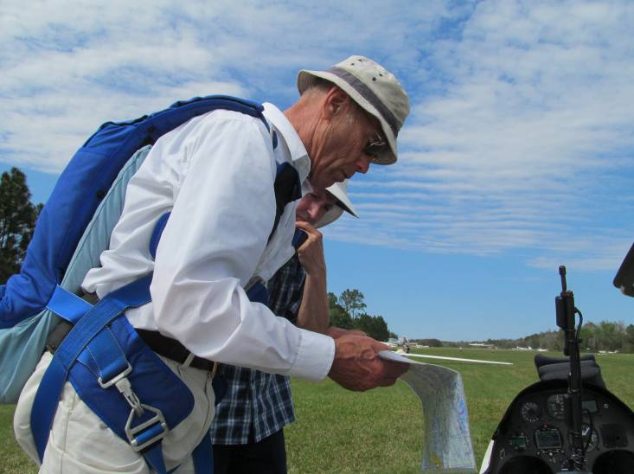
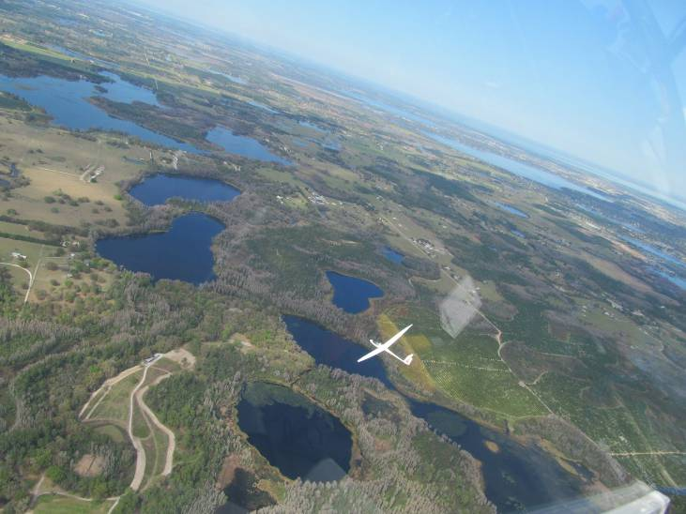
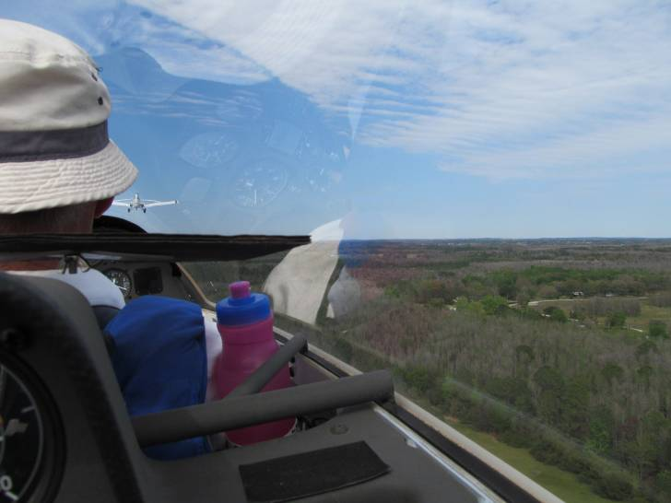
1.1.4 The Actual Flight
15:30 Karl suggests to a fellow pilot where he thinks we should try to go…Stratus layer in the background.
While we were waiting for the starting information, I was standing in the bright sun next to the glider and suddenly my nose started to run and I had to sneeze every few seconds which is exhausting in particular when you are out of tissue paper. As I walked back to the van to stock up on Kleenex, I kept wondering why I had such a powerful allergy attack.

I had not suffered from any significant hay fever allergy since we are living in Florida. But I do remember that when I visited our son in Sacramento, California, a couple years ago during a windy week in spring that I had the worst attack of my life. This felt very similar except that I did not have any medication handy since I did not expect this at all.
15:40 On tow to 2000’ heading NE toward the ponds.

My conclusion was that there were some trees blooming close by I am highly allergic to. The only solution under the circumstances was to get out of the sun and relax as much as possible until I was in the glider.
15:56 Since this was the only thermal Karl was soon surrounded by other gliders circling outside and below him.

There was no way I would have missed the flight with Karl because of a stupid allergy attack. Luckily the attack subsided and other than being very quiet at the beginning I recovered nicely during the flight. But it hit me again when we drove back to our hotel in Clermont.

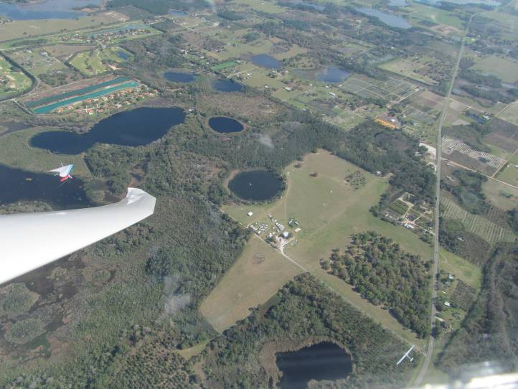
When we were ready for take-off at around 15:30, Karl was approached by some pilots who wanted to follow him on his task. He outlined a possible flight to the North where the sun was not covered by the stratus layer shown in the picture back ground.
16:10 Circling with hang gliders and others over their field on Hwy. 33

A few minutes later we were on tow heading NE towards the ponds in the vicinity of the Seminole airfield. Off tow at ~2000’ Karl tried to get higher in a relatively weak thermal over the ponds.

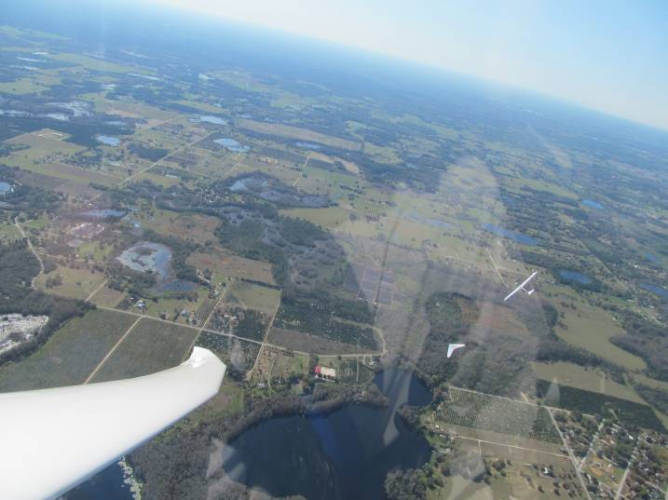
Since this was the only thermal around we were soon in the company of two other gliders circling outside and below us. Karl carefully centered the lift and slowly but steadily we climbed to 2300’ and then a few hundred feet further north to 2600’. To my surprise Karl just took off without trying to get higher and headed toward the Hang Glider Port a few miles to the north on Hwy. 33.
16:12 After a few minutes Karl had out-climbed everybody and we moved on….(Hang Glider with dangling rope)

There we saw a hang glider in good lift and I immediately understood why Karl abandoned the previous thermal before I would have, had I flown by myself. It did not take long before the other gliders joined us including another hang glider that seemed to have a tow rope dangling behind it. (See *Flash Back insert below).

Anyway, I hope the hang glider on Hwy. 33 was not in any danger and knew what was dangling below it. (I wished I knew what frequencies the hang gliders are using to communicate but since I have never flown such an aircraft I have no idea).

Karl quickly out-climbed everybody in the gaggle, including the hang glider, which surprised me because I usually cannot reach their altitude when I fly with them. But I also observed that everybody else in the gaggle circled on the outside of us, obviously flying wider circles with less banking at about the same speed.
Karl left the thermal at 3400’ and flew further north along Hwy. 33 toward Groveland where we crossed Hwy. 50. As we approached the Grass Roots airpark we were down to 2000’ which would have made me pretty nervous had I been by myself, but with Karl in command it was just a piece of cake. He pointed toward a smoke plume of a fire further north on the east side of Hwy. 33, close to the Tex Merritt airstrip.
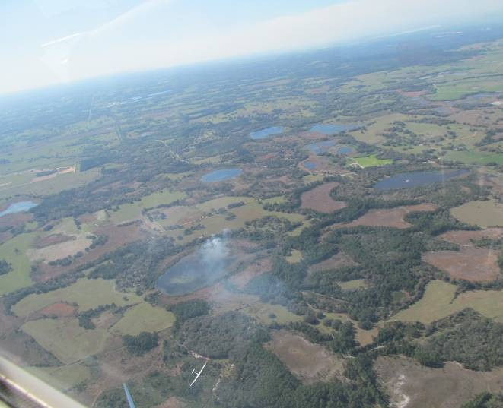
*Flash Back
This dangling rope reminded me of a scary incident in my “way early” soaring life, when I was towing a glider to a ridge close to our glider port (in Switzerland). The glider pilot did not release the towline and made a sharp turn toward the ridge. This unexpected drag stalled my tow plane and the trees came awfully fast and close to me after I had release the tow rope on my side.
Of course, the glider had the tow rope still dangling from its hook and ridge soaring with this long tow rope hanging down did not look very safe to me. However, this was way before gliders were equipped with radios and my challenge was to tell the glider pilot to drop the tow rope. I flew next to it and tried to motion that he should look down, but of course he could not see the rope. Then I pointed to the tail of the Stinson (tow plane) to show that I did not have the rope on it.
I guess this was all too abstract and because there is no signal for this situation (if there is one, I certainly did not know it), so I motioned the glider pilot to follow me back to the glider port. This he understood and on the way there I flew next to him and a little ahead and fishtailed slightly forth and back. After a few minutes he figured out that the rope on my tow plane was missing and concluded that he still had it on his nose.
It all worked out well and the glider did drop the rope at the beginning of the airstrip before landing (long). However, after this experience I never towed gliders as close to the ridge as I did before….and I also know that the weak links in the tow ropes do not break in such a case.

16:21 Karl flew into the smoke plume of this fire…
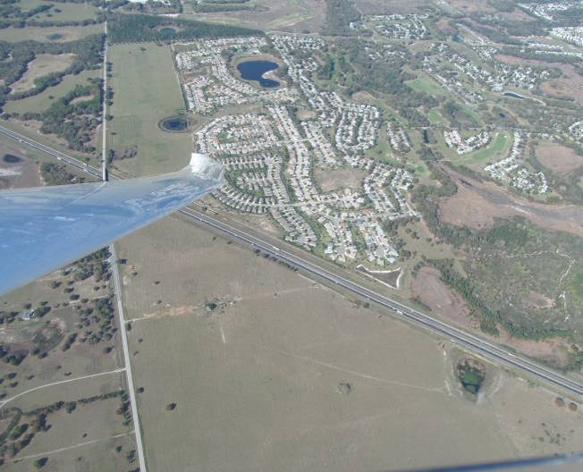
On the way there I was wondering what Karl would do once we got to the smoke. I usually try to stay away from fires whenever I can because I had a bad experience some time ago. What happened was that when I flew into a black smoke plume my glider stunk of smoke for weeks afterwards. In addition I had collected a sticky black film on the leading edge of the wings and the stabilizer. To make matters worse, after I landed, another self launch pilot made a scary statement that an ember could have ignited my fuel tank (through the drain in the wheel well at the bottom of the fuselage).
16:27 Just before crossing the Florida Turnpike heading toward Leesburg

Anyway, I was curious what Karl would do in the smoke. First of all, unlike what I used to do, Karl did not fly into the smoke close to the fire. We were probably a mile away from the fire. I also speculated that he did not really use the rising air in the smoke plume directly, but rather a secondary effect. My initial theory, hat the rising air in the smoke column would “encourage” thermal development in the area it flows over, turned out to be incorrect. Karl explained to me (after reading my first draft of this write-up), that small fires do not contribute much to a thermal. However, the smoke is drawn into the existing thermals and rises with them, thus marking where the lift is. Therefore all we have to do is look for a smoke column above the plume, and this is where the lift is. This explanation sounds a lot better than mine.
Some smoke gets carried up by the thermal thus creating hazy markers
Fire
Rising Smoke Plume
Wind direction
Look for hazy markers above the smoke plume:

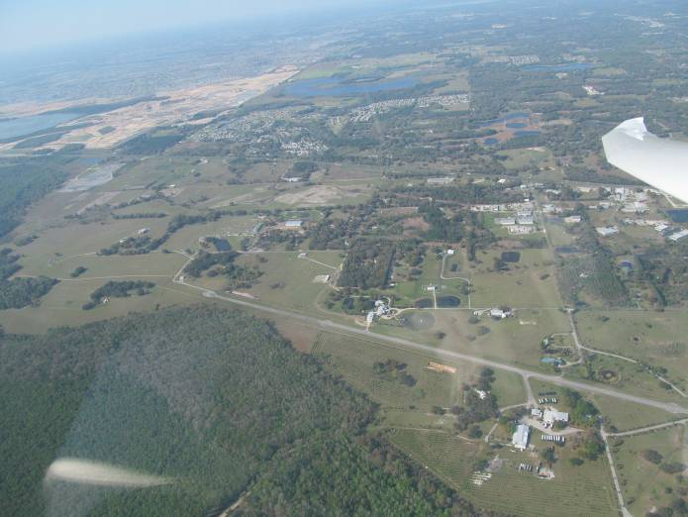
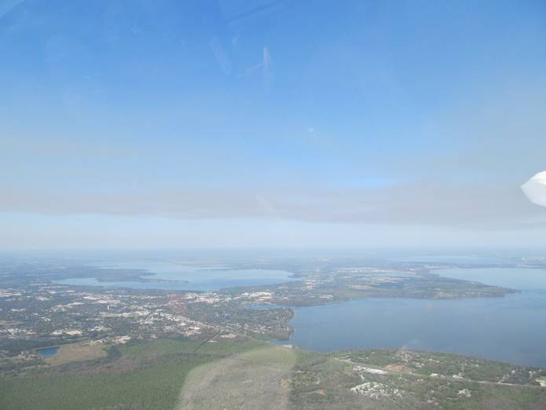
Obviously Karl identified the thermal by the rising smoke above the plume and in no time we were back up to 3500’ and proceeded toward Leesburg. At ~16:30 Karl turned around heading south over the Flying Baron airfield. This is an impressive private airport with a stately mansion and several other attached buildings.
16:33 Over the impressive Flying Baron runway and compound
16:30 Leesburg ahead….Shortly after this, Karl turned South over the Flying Baron….

We crossed the Turnpike at 16:35 at 2500’ and Karl heading back to the Tex Merritt fire where we arrived at 1700’ and Karl got us back up to 2100’. From there we flew toward the Grass-Roots airpark (which was approximately ~3 mile east-south-east of the Tex Merritt fire). where

We arrived at the Grass-Roots airpark at 16:48, at a whopping 1400 feet. This is way below my comfort level when I am flying by myself and it is even below where I usually start the engine.

Of course, I had no doubt that Karl would find lift there and get us home safely…. until he mentioned that he had landed out there a couple days earlier and it was a good place to land….

Oops? Was I too optimistic about Karl getting us out of there? I certainly did not want to land out after this wonderful flight.

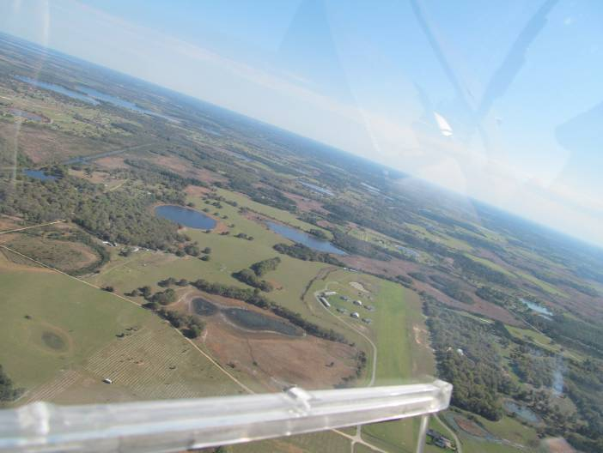
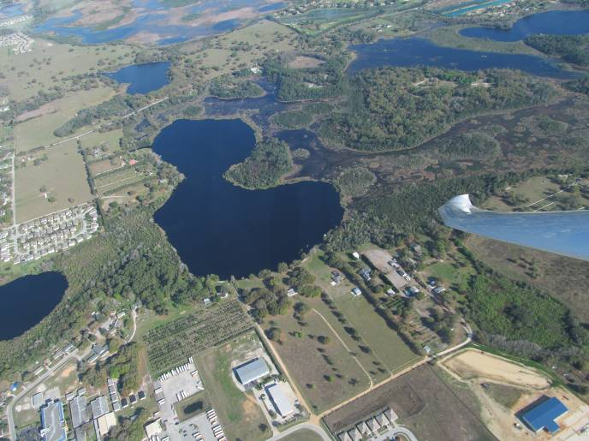
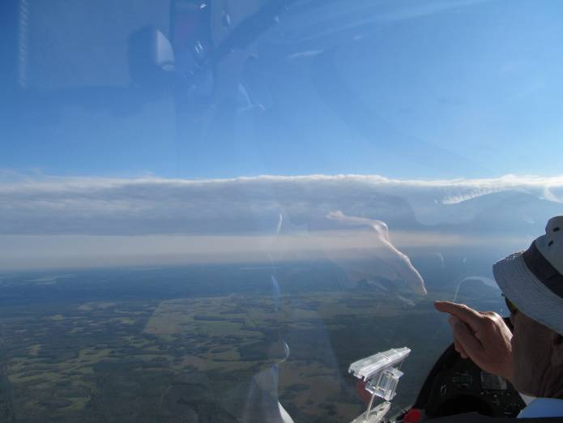
A few thoughts went through my mind: Would we be able to tow out from Grass-Roots to Seminole or would Iris have to get us with the trailer? I did not dare asking….
16:50 At the north end of the Grass Roots airpark at 1400’
17:05 Finding lift over a school bus parking lot over Groveland
17:30 Karl is pointing at the Burntwood Ranch Airport

But I quickly regained my confidence when Karl pointed out a bald eagle to me that was soaring over the north end of the airfield. The eagle did not leave when we joined it and stayed with us for the entire time we were in the thermal. First the eagle was circling in the opposite direction and I joked with Karl that the eagle obviously did not know the gaggle rules. But after a few turns it changed the direction and flew with us.

We left the Grass-Roots thermal at 15:56 at 2300’ and headed south toward Groveland.

By the way, I tried so hard to take pictures of the bald eagle (and all the other birds that helped us out along the way), but none of the pictures turned out satisfactory.

We arrived at Groveland at ~17:00 at 1500’ and Karl found some more lift, first over a school bus parking lot that got us back up to 2000’ and later, a mile further south we got to 2900’. This altitude was not quite enough to get us back to Seminole but I was confident that Karl would get us home safely since he had recovered from below 1500’ already twice that afternoon.
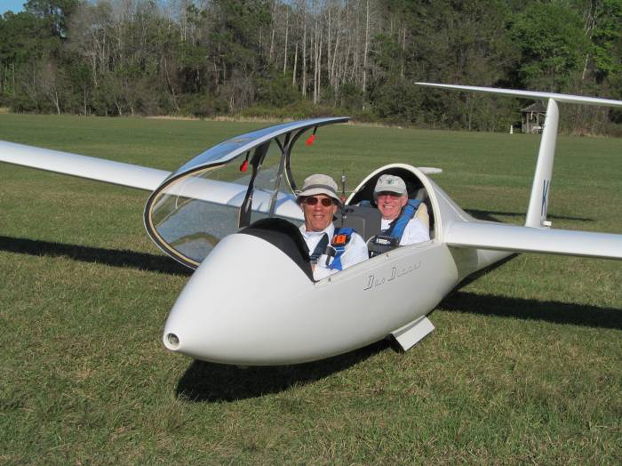
And sure enough, less than 5 minutes later, over the hang glider field on Hwy. 33, we reached the highest altitude of the day of 4565’, much higher than we needed to be to get back to Seminole and there was still plenty of lift around.
17:45 Happy Landing at Seminole after a great flight. Thank you Karl!

As we flew over the Seminole glider port Karl asked me if I was hungry and I said no and so we flew further south toward the Burntwood Ranch Airport.

It still amazes me how quickly you can get into a very sparsely populated area in Florida. As we flew just a few miles south-west from Seminole there was this open and untouched sector between County Road CR 471 and Hwy. 33. This is where the Burntwood Ranch is. I would not have seen the airstrip if Karl had not pointed it out to me. At 17:30 we were within the vicinity of Burntwood and Karl turned around and brought us safely back to Seminole.
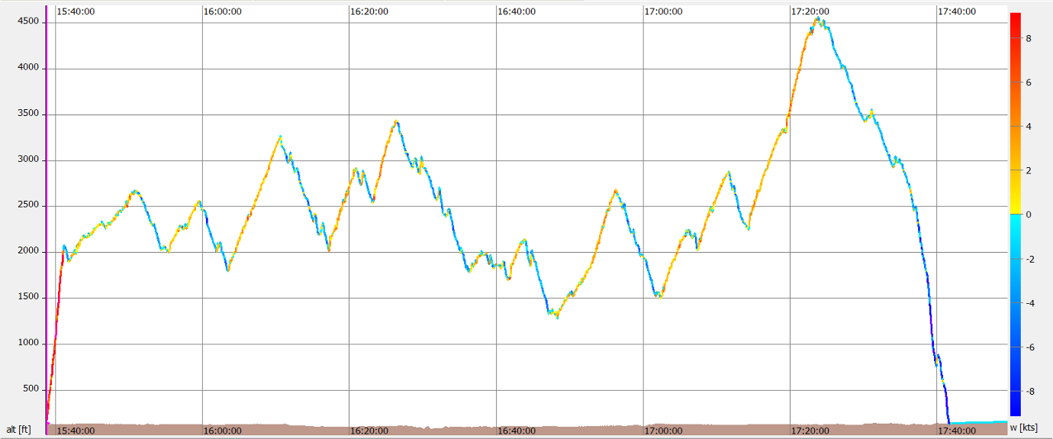
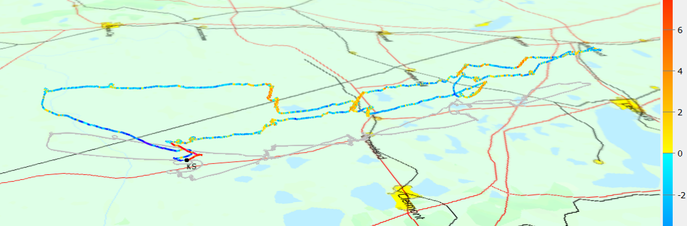
3
6. More Lift near the Turnpike (Flying Baron) gets us from 2600’ to 3400’

9. Getting “Scary” low at the Grass Roots Airpark
2. Slowly climbing to 2600’ next to the Ponds NE of the Seminole Airfield

4. First good Lift near Groveland from 1800’to 3200’
8. Back at the Turnpike
3. Heading North to the Hang Glider Field
7. Heading toward Leesburg and turning around
5. In the Smoke Plume from 2000’ to 2800’
1
2
4
54
9
7
8
1. 15:42
Tow to 2000’
12
13
6
11. Another Low Save at Groveland
13. Over Seminole heading for the Burntwood Ranch
12. The best Thermal of the Day at the Hang Glider Port
10. A Low-Save at the Grass-Roots Airpark
14. At the Burntwood Ranch
Returning back to Seminole
14. At the Burntwood Ranch
Returning back to Seminole
14
1.1.6 Annotated GPS Trace and Altitude Profile

1.1.5 What did I Learn?

Flying in the blue is certainly one of my weaknesses when I fly cross country and there were numerous situations where I was amazed how much better it was to fly with Karl than me. It is truly fun and humbling to watch what the expert is doing and compare it with what I would have done in the same situation. Let me group my observations according to the four phases of our flight:

1. Goals and Task Declaration:
- Set a goal for each flight and declare a task.
- Since the contest task was cancelled Karl picked a challenging flight to the North. Basically to Leesburg (Flying Baron) and back, because it looked like there was a better chance to get from under the stratus layer and into the sun.

2. The First Glide:
- Karl tried to get as high as reasonable over the local ponds but it was a slow climb from 2000’ to 2300’ and Karl eventually started the task by flying north towards the first turnpoint.
- This is probably the area where I make the biggest mistake because I have imposed this arbitrary altitude minimum of 4000’ before I allow myself start my cross country task.
- This is a colossal waste of time and effort because there are many situations, such as the one we encountered at Seminole, where I could never leave the home port.
- Karl on the other hand showed me that you can start the task at any altitude if you have a safe landing alternative.
- This means I do not need more that 2500’ to leave La Belle for a cross country flight. This will get me half way to Immokalee and if I cannot find any lift in the first 10 miles, then I can still glide back and land at La Belle. Of course, I would be too low to restart the engine over the La Belle runway, which was included in my 4000’ minimum. But I could just land and then take off again, as Nico suggested.

3. The Flight:
- Always try the upwind side of a promising cloud first.
- Do not waste time entering and centering lift when you cannot gain a significant amount of altitude, such as 1000 feet.
- Observe the lift patterns of the thermals, and figure out when the climb rate falls below a certain level.
- Resist the temptation to stay in a thermal for too long (one of my biggest hang-ups!).
- Try to find thermals that are in their early phase of development. The only marker might be a wisp or a veil of haze.
- Circling birds are the best markers for lift, but the birds might leave when you enter the thermal they are in. To follow them is not advisable.
- Smoke can help Identify thermals. ***See separate explanation below.
- Observe the changes in weather and wind conditions.
- It is possible to find and stay in lift at 1500’. I always thought that the thermals are so narrow at this altitude that you have to bank very steeply to be able to utilize the lift. But Karl never banked more than 45 degrees during his low saves, even below 1500’.
- Do not deviate from the course unless there is a significant benefit in lift potential.
- The best looking clouds are not always yielding the best lift.
- Probably the most significant mistake I am regularly making is to turn into the thermal when the lift pushes one wing up.
- ***What I learned from Karl is to use the rotation to turn around instead of fighting it by pushing down the wing against the lift and trying to enter the lift right away. It became obvious once I thought about it, that even with a good roll rate of a modern glider, it takes too long to turn against the lift and I usually miss the thermal anyway and have to go around. Why not turn around immediately and enter the center of the lift? ****Se separate explanation below

4. The Final Glide
- When you have reached the final glide altitude, speed up when you gain additional altitude and slow down when you encounter sink or headwind.
- Do not add additional altitude as safety margin (another mistake I consistently make!). Your safety margin should be built into the final glide altitude.
- Trust your instrumentation.
- Put down the landing gear when you are making the decision to land. Check again when you are in the landing pattern and go through the checklist.
I am probably missing some other observations I made but I will add them to the list when I remember them.

** Karl’s Clarification about Smoke:

……One aspect of the flight you discussed was the smoke we noticed near Tex Merritt airport on the way north and south.
Some smoke gets carried up by the thermal thus creating hazy markers
Fire
Rising Smoke Plume
Wind direction
My pictorial interpretation of Karl’s explanation: Look for hazy markers above the smoke plume:

For small fires like this (not the big forest fires with visible, towering flames) the fire doesn't contribute much to the propagation of a thermal. Rather the smoke is drawn into thermals that are nearby anyway and thus these small fires can be useful. The smoke had a large horizontal component to it before any bubbles rose, so it indicated where to look. In this case, considerable downwind from the fire.

For the larger forest wild fires, it is obvious where to find the lift because the smoke is rising straight up. In these cases, the fire is the source of the heat that produced the thermal……

Just for reference, below is my first draft speculation which Karl responded to with the excerpts above.

……… Karl flew into the smoke far away from the fire, and I think he did not really use the rising air in the smoke plume directly but rather its secondary trigger effect. My speculation is hat the rising air in the smoke column “encourages” thermal development in the area it flows over because it sucks up the air below it, which can trigger other thermals.
Secondary
Thermals
Hugo’s Speculation: The Suction Force Created by the Rising and Expanding Air-mass of the Smoke Plume triggers Hot Air Bubbles that develop into Thermals….
Fire
Smoke Plume
Hot Air Bubbles

When I looked at the direction of our climbs in the smoke, it was obvious that we did not climb at the angle of the smoke plume but rather perpendicular to the surface and mostly above the smoke…..

***Watching Karl deal with a strong Bump under the left Wing:
I also learned from Karl to use the rotation to turn around instead of fighting it by pushing down the wing against the lift and trying to enter the lift right away. It became obvious once I thought about it, that even with a good roll rate of a modern glider, it takes too long to turn against the lift. I usually miss the thermal anyway and have to go around. Why not turn around immediately and enter the center of the lift?

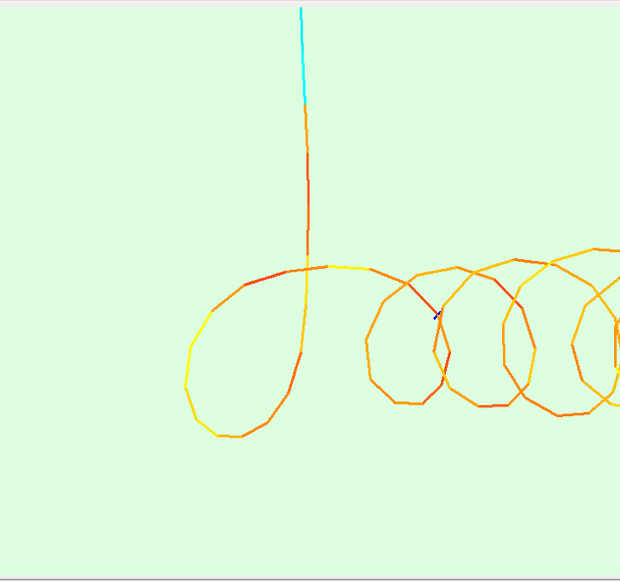
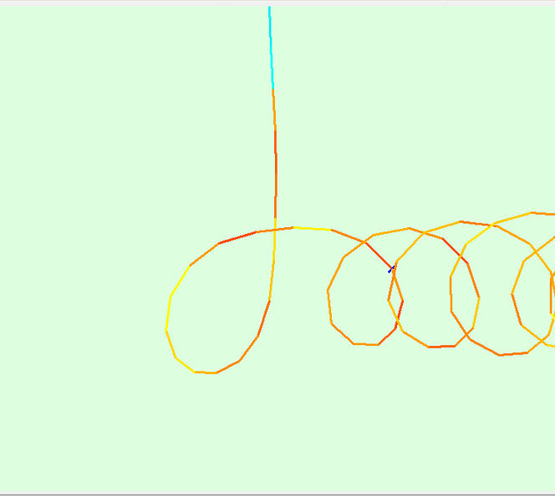
Strong bump under left wing
Enter the thermal later
Fight the rotation and make a left turn against the lift
(Stick to the left)
The rotation against the lift momentum delays the turn because of the roll rate limitation
Strong Bump under left Wing
Case #2 (Hugo)
Turn overshoot delays entry into lift
Strong bump under left wing

Utilize the rotation and make a right turn away from the lift (push-up force)
(Stick to the Right)
Enter the thermal sooner
Strong Bump under left Wing
Case #1 (Karl)

----------------------------- End of Flight # 1 ------------------------------------

2. Year to Date Flights and Hours Compared to last Year

 | 2013 |  |  | 2014 |  | YTD: 2014-2013
Month | Flights | Hours | Month | Flights | Hours | Flights | Hours
Jan | 1 | 1.9 | Jan | 0 | 0 | -1 | -1.9
Feb | 4 | 14.5 | Feb | 3 | 10.0 | -1 | -4.5
Mar | 0 | 0 | Mar | 1** | 2 | 0 | -2.5
Apr | 1 | 4.5 | Apr
May | 1 | 2 | May
Jun | 0 | 0 | Jun
Jul | 0 | 0 | Jul
Aug | 1 | 2.2 | Aug
Sept | 3 BFR | 0.5 | Sept
Oct | 3 | 7.8 | Oct
Nov | 1 | 4.6 | Nov
Dec | 1 | 1.8 | Dec
YTD | 16 | 39.8 | YTD
** Flight with Karl Striedieck

Seminole Senior Contest 2015
I have already scheduled a ride with Karl Striedieck for the Seminole Senior Contest on Monday, 2015…..

This is it for right now. Best wishes from
Hugo and Cornelia Vifian
hvifian@aol.com


-------------------- End of Soaring Summary #2 from March 2014 ---------------------

Smoke
Plume

